St Bernadette’s, Princess Road, Manchester M20 1HH

Contents
- About Southway Housing Trust
- Proposal Summary
- Homes Provided
- Design and Heritage
- Materials and Appearance
- Community Feature Wall
- Consultation Boards

About Southway Housing Trust
Southway Housing Trust owns more than 6,500 homes across Greater Manchester. The organisation aims to provide quality homes and services, support thriving communities and increase its housing stock by 2030.

Proposal Summary
The former St Bernadette’s church site is proposed for redevelopment into 34 apartments for residents aged 55 and over. All homes are proposed as social rent properties.

Homes Provided
The development would provide 22 one-bedroom two-person homes, 8 two-bedroom three-person homes and 4 wheelchair accessible M4(3) homes, making 34 homes in total.

Design and Heritage
The church building is not proposed for retention because assessments concluded that conversion would be impractical. Elements of the church’s character and history may be reused within the new development where feasible.

Materials and Appearance
The proposed building uses grey and cream brickwork, art-stone detailing, banding features and pitched roof forms that reference local character.

Community Feature Wall
A communal entrance feature wall is proposed to display community memories and historic photographs connected with St Bernadette’s.

Consultation Board 1
Alternative text: Consultation board 1 showing architectural proposals, plans, elevations, site context and supporting images for the St Bernadette’s redevelopment proposal.
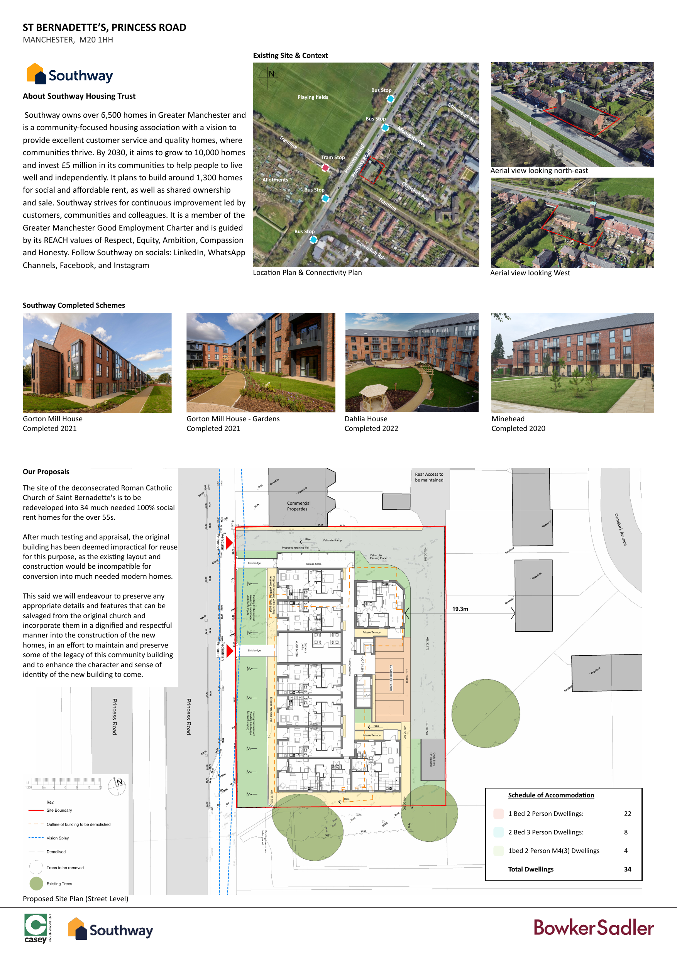

Consultation Board 2
Alternative text: Consultation board 2 showing architectural proposals, plans, elevations, site context and supporting images for the St Bernadette’s redevelopment proposal.
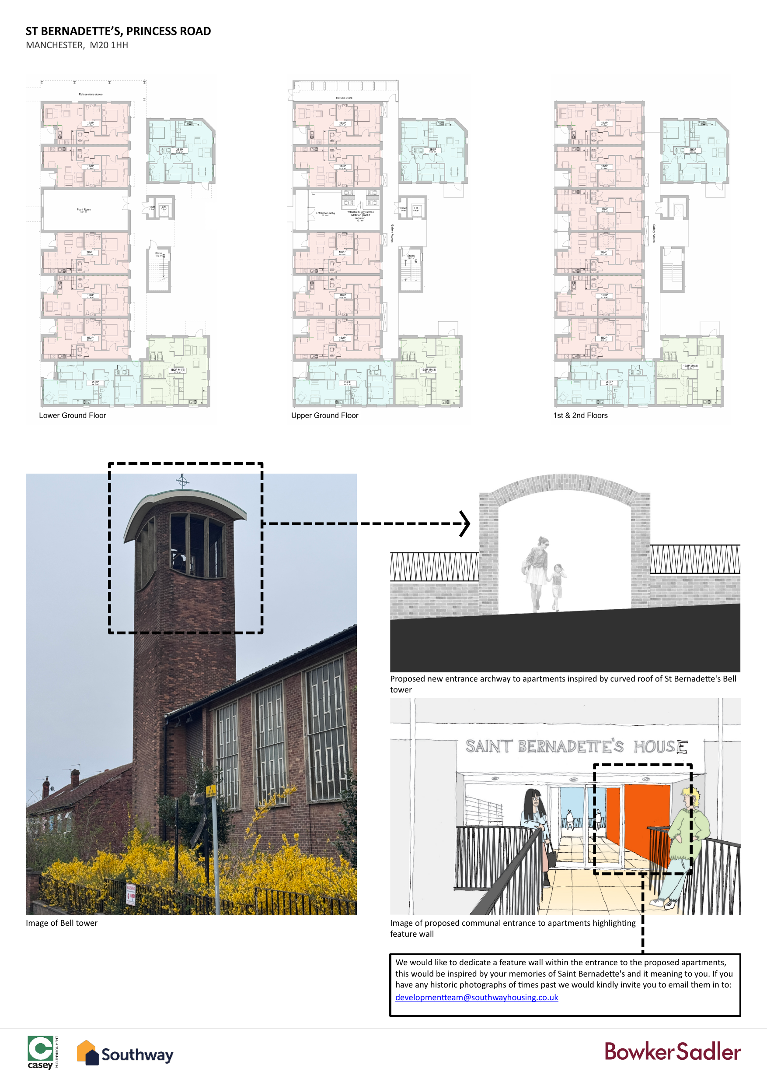

Consultation Board 3
Alternative text: Consultation board 3 showing architectural proposals, plans, elevations, site context and supporting images for the St Bernadette’s redevelopment proposal.
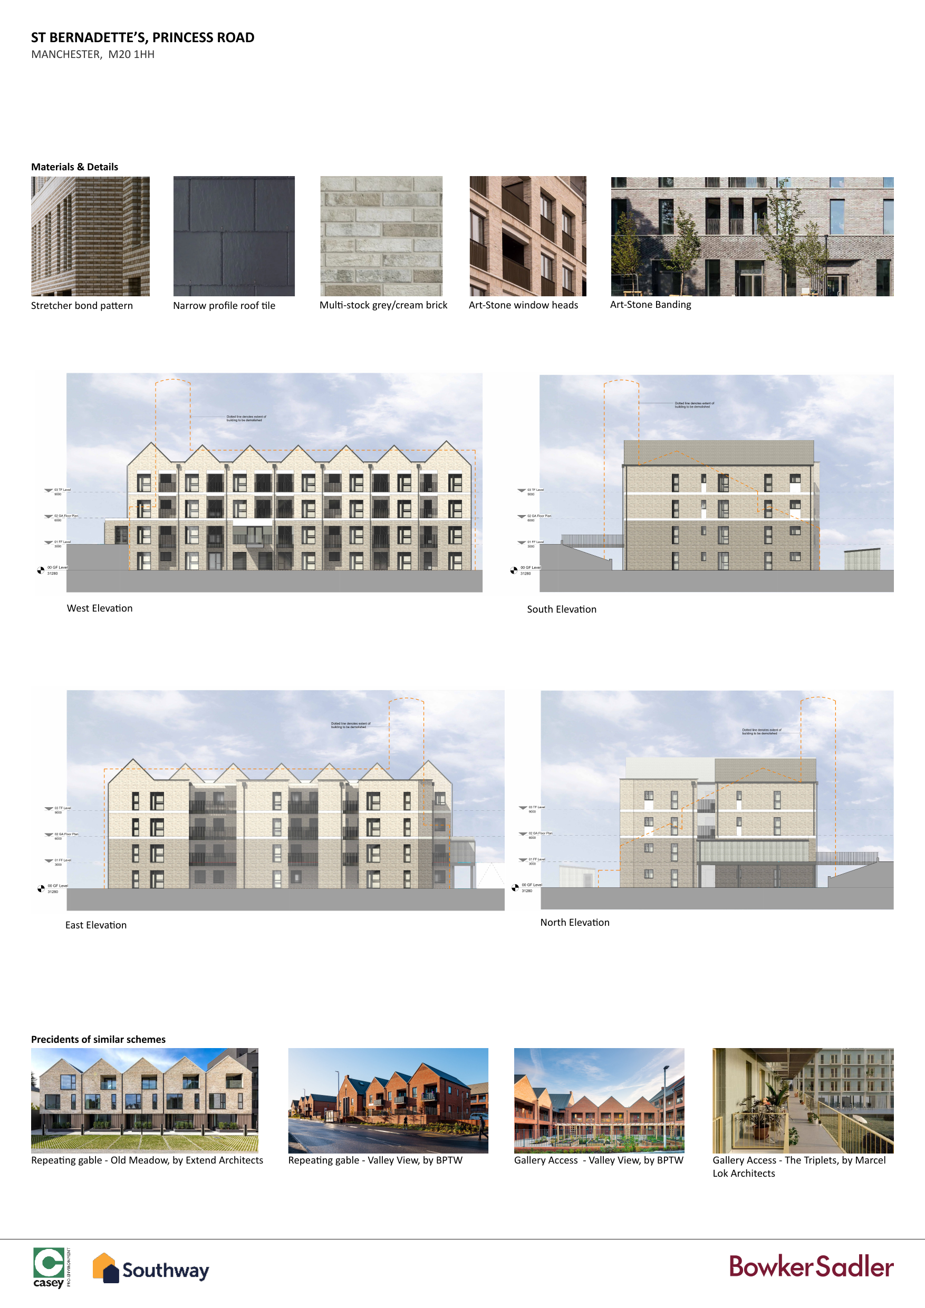

Consultation Board 4
Alternative text: Consultation board 4 showing architectural proposals, plans, elevations, site context and supporting images for the St Bernadette’s redevelopment proposal.
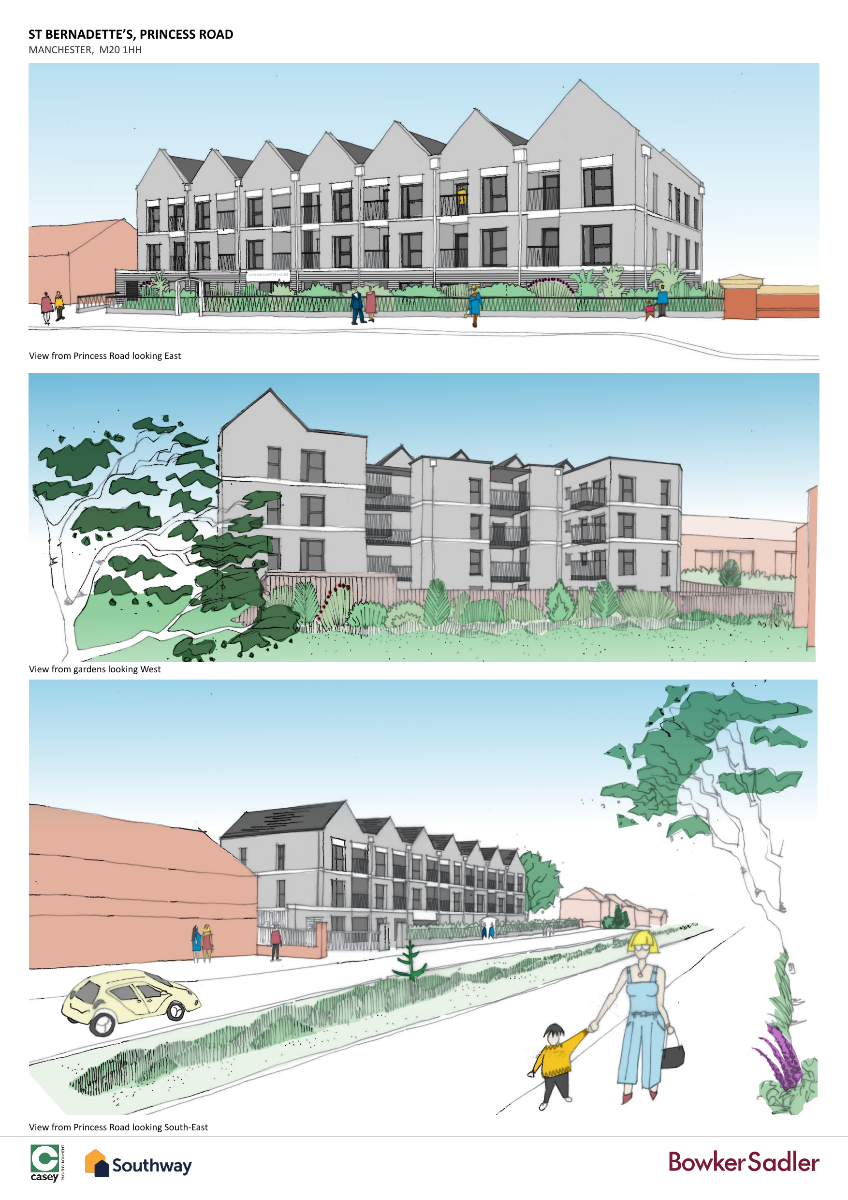

Consultation Board 5
Alternative text: Consultation board 5 showing architectural proposals, plans, elevations, site context and supporting images for the St Bernadette’s redevelopment proposal.


